**Random Forest Algorithm:**

Random forests or random decision forests are an ensemble learning method for classification, regression and other tasks, that operate by constructing a multitude of decision trees at training time and outputting the class that is the mode of the classes (classification) or mean prediction (regression) of the individual trees. Random decision forests correct for decision trees’ habit of over fitting to their training set. Random forest is a type of supervised machine learning algorithm based on [ensemble learning](https://en.wikipedia.org/wiki/Ensemble_learning). Ensemble learning is a type of learning where you join different types of algorithms or same algorithm multiple times to form a more powerful prediction model. The [random forest](https://en.wikipedia.org/wiki/Random_forest) algorithm combines multiple algorithm of the same type i.e. multiple decision trees*,* resulting in aforest of trees*,* hence the name "Random Forest". The random forest algorithm can be used for both regression and classification tasks.

The following are the basic steps involved in performing the random forest algorithm:

* Pick N random records from the dataset.
* Build a decision tree based on these N records.
* Choose the number of trees you want in your algorithm and repeat steps 1 and 2.

In case of a regression problem, for a new record, each tree in the forest predicts a value for Y (output). The final value can be calculated by taking the average of all the values predicted by all the trees in forest. Or, in case of a classification problem, each tree in the forest predicts the category to which the new record belongs. Finally, the new record is assigned to the category that wins the majority vote.

MODULE DIAGRAM

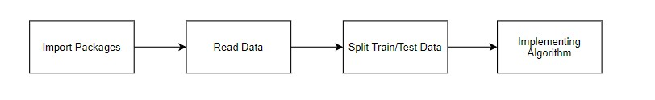

GIVEN INPUT EXPECTED OUTPUT

input : data

output : getting accuracy